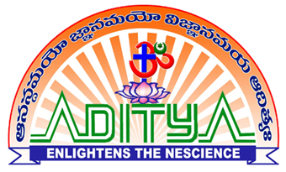 | ADITYA COLLEGE OF ENGINEERING :: SURAMPALEM
FACULTY PROFILE

Personal Profile

Name | MALLIREDDY NARESH  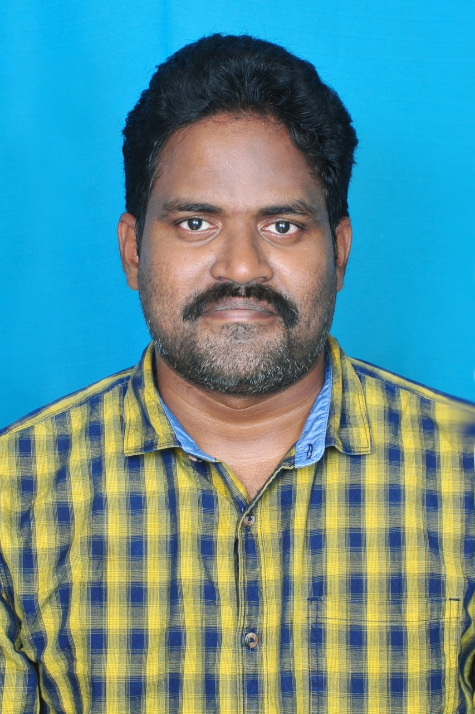
Date of Birth | 16-08-1985
Address | Department of CSE,
Aditya College of Engineering,
Surampalem-533437
 | East Godavari District, Andhra Pradesh
Date of Joining | 06-06-2022

Vidwan Profile Profile URL: https://vidwan.inflibnet.ac.in/profile/317811

Academic Profile

Qualification |  | Name of the Board/University | Year of Passing
B.Tech. |  | PONDICHERRY UNIVERSITY | 2006
M.Tech. |  | PONDICHERRY UNIVERSITY | 2009
Ph.D.(Pursuing) |  | ANNA UNIVERSITY, CHENNAI | -
Others
 | Professional Experience

Designation | Name of the Employer | Length of Service
Associate Professor | Aditya College of Engineering | Till Date
Assistant Professor | Aditya College of Engineering | 1 Year
Assistant Professor | Hindusthan College of Engineering and Technology, Coimbatore | 7 Years
Assistant Professor | Nehru Institute of Engineering and Technology | 3 Years
Assistant Professor | Srinivasan Engineering College, Perambalur | 1 Year
Assistant Professor | Nightingale Engineering College for Women, Visakhapatnam | 1 Year
Lecturer | Dhanalakshmi Srinivasan Engineering College, Perambalur | 1 Year

Memberships of Professional Societies:
IWS- L01319
IAENG - 349105

Research Publications

National Conference | International Conference | National Journals | International Journals | Books / Book Chapters | Patents
 | 3 |  | 8 |  | 2

Seminars/ Workshop/ FDPs attended

Seminars | Workshops | FDPs
20 | 15 | 20

NPTEL FDPs / Professional Certification

NPTEL | Coursera | Udemy | Others
01 | 06

Other Information

1)

